Book | Date Read | Fun Facts We Learned
A Year on the Farm by Holly Dufeck
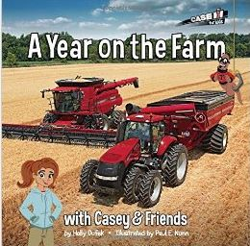

Curious George: Farm to Table by H.A. Rey
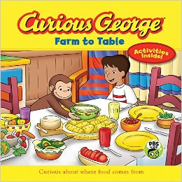

Diary of a Farmer by Angela Royston
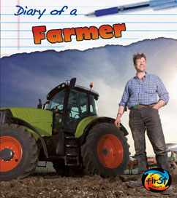

How did that get in my Lunchbox? By Chris Butterworth
